**Google Cloud Fundamentals: Getting Started with Compute Engine**

Toggle Lab Panel



**Google Cloud Fundamentals: Getting Started with Compute Engine**

25 minutes Free

Rate Lab

**Overview**

In this lab, you will create virtual machines (VMs) and connect to them. You will also create connections between the instances.

**Objectives**

In this lab, you will learn how to perform the following tasks:

* Create a Compute Engine virtual machine using the Google Cloud Platform (GCP) Console.
* Create a Compute Engine virtual machine using the gcloud command-line interface.
* Connect between the two instances.

**Task 1: Sign in to the Google Cloud Platform (GCP) Console**

For each lab, you get a new GCP project and set of resources for a fixed time at no cost.

1. Make sure you signed into Qwiklabs using an **incognito window**.
2. Note the lab's access time (for example, img/time.pngand make sure you can finish in that time block.

There is no pause feature. You can restart if needed, but you have to start at the beginning.

1. When ready, click img/start_lab.png.
2. Note your lab credentials. You will use them to sign in to Cloud Platform Console. 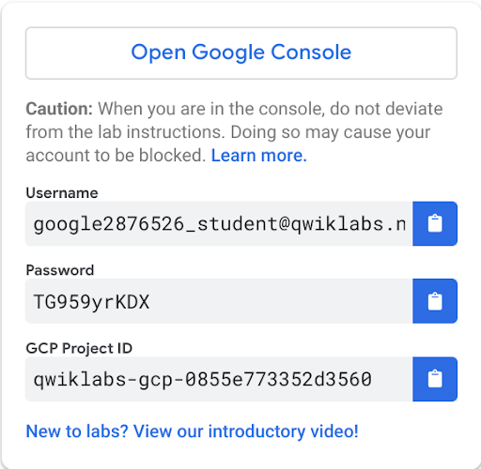
3. Click **Open Google Console**.
4. Click **Use another account** and copy/paste credentials for **this** lab into the prompts.

If you use other credentials, you'll get errors or **incur charges**.

1. Accept the terms and skip the recovery resource page.

Do not click **End Lab** unless you are finished with the lab or want to restart it. This clears your work and removes the project.

**Task 2: Create a virtual machine using the GCP Console**

1. In the **Navigation menu** (), click **Compute Engine** > **VM instances**.
2. Click **Create**.
3. On the **Create an Instance** page, for **Name**, type my-vm-1
4. For **Region** and **Zone**, select the region and zone assigned by Qwiklabs.
5. For **Machine type**, accept the default.
6. For **Boot disk**, if the **Image** shown is not **Debian GNU/Linux 9 (stretch)**, click **Change** and select **Debian GNU/Linux 9 (stretch)**.
7. Leave the defaults for **Identity and API access** unmodified.

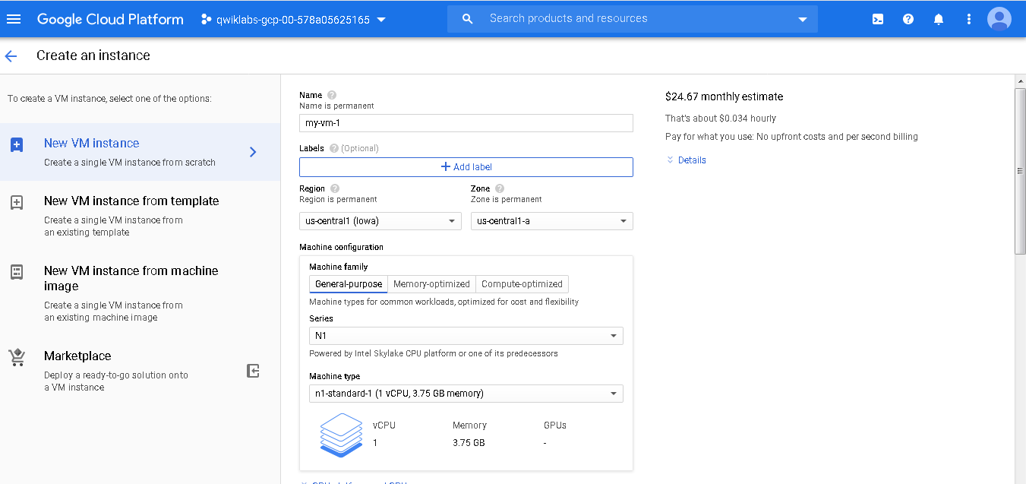

1. For Firewall, click **Allow HTTP traffic**.

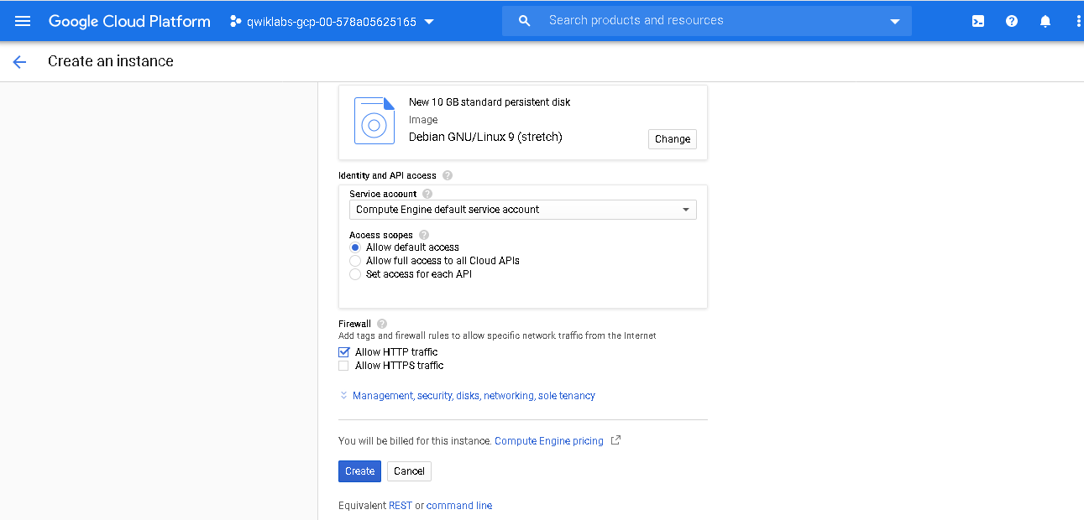

1. Leave all other defaults unmodified.
2. To create and launch the VM, click **Create**.

**Note**: The VM can take about two minutes to launch and be fully available for use.

Click *Check my progress* to verify the objective. Create a virtual machine using the GCP Console

**Task 3: Create a virtual machine using the gcloud command line**

1. In GCP console, on the top right toolbar, click the Open Cloud Shell button.

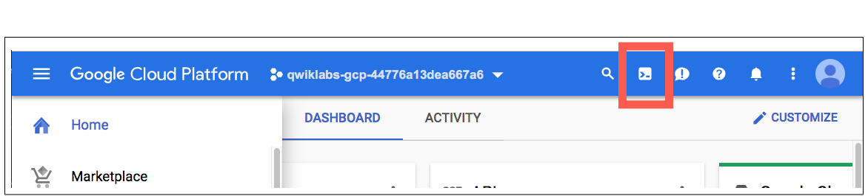

1. Click **Continue**. 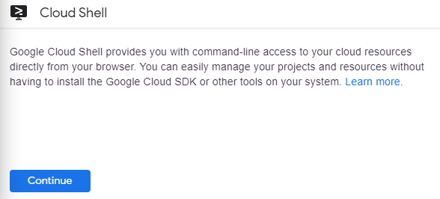
2. To display a list of all the zones in the region to which Qwiklabs assigned you, enter this partial command gcloud compute zones list | grep followed by the region that Qwiklabs or your instructor assigned you to.

Your completed command will look like this:

gcloud compute zones list | grep us-central1

• Choose a zone from that list other than the zone to which Qwiklabs assigned you. For example, if Qwiklabs assigned you to region us-central1 and zone us-central1-a you might choose zone us-central1-b.

• To set your default zone to the one you just chose, enter this partial command gcloud config set compute/zone followed by the zone you chose.

Your completed command will look like this:

gcloud config set compute/zone us-central1-b

To create a VM instance called **my-vm-2** in that zone, execute this command:

gcloud compute instances create "my-vm-2" \

--machine-type "n1-standard-1" \

--image-project "debian-cloud" \

--image "debian-9-stretch-v20190213" \

--subnet "default"

**Note**: The VM can take about two minutes to launch and be fully available for use.

1. To close the Cloud Shell, execute the following command:
2. 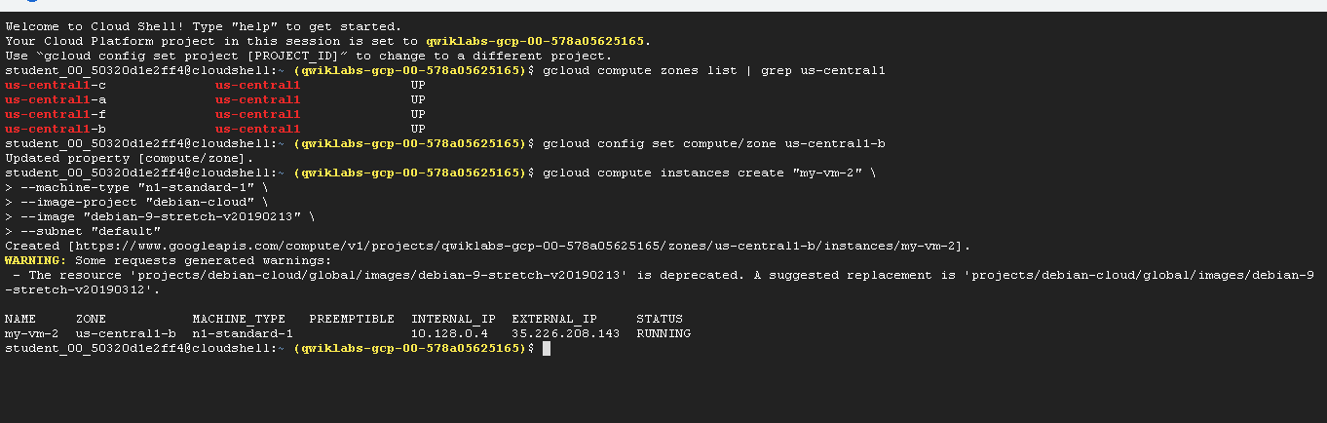exit

Click *Check my progress* to verify the objective. Create a virtual machine using the gcloud command line

**Task 4: Connect between VM instances**

1. In the **Navigation menu** (), click **Compute Engine > VM instances**.

You will see the two VM instances you created, each in a different zone.

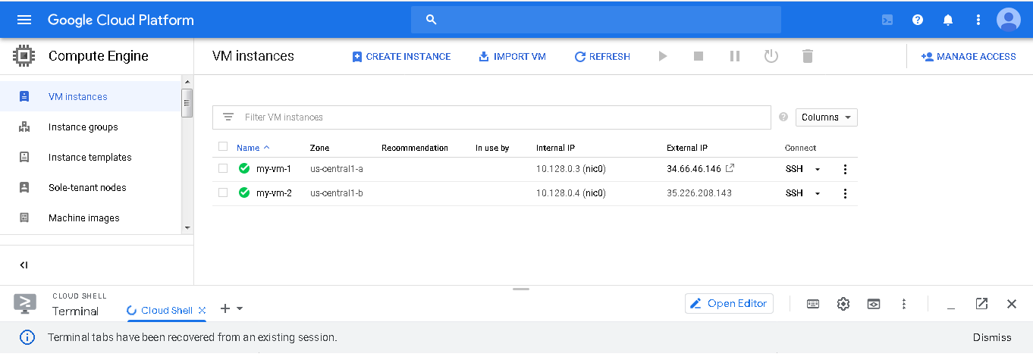

Notice that the Internal IP addresses of these two instances share the first three bytes in common. They reside on the same subnet in their Google Cloud VPC even though they are in different zones.

1. To open a command prompt on the **my-vm-2** instance, click **SSH** in its row in the **VM instances** list.
2. Use the ping command to confirm that **my-vm-2** can reach **my-vm-1** over the network:
3. ping my-vm-1

• Notice that the output of the ping command reveals that the complete hostname of **my-vm-1** is **my-vm-1.c.PROJECT\_ID.internal**, where PROJECT\_ID is the name of your Google Cloud Platform project. GCP automatically supplies Domain Name Service (DNS) resolution for the internal IP addresses of VM instances.

• Press **Ctrl+C** to abort the ping command.

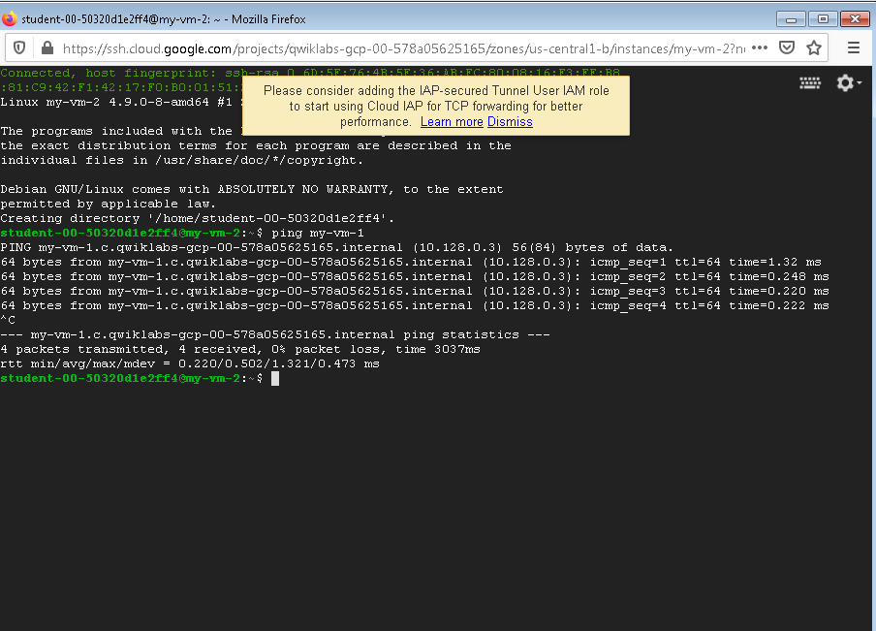

• Use the **ssh** command to open a command prompt on **my-vm-1**:

ssh my-vm-1

• If you are prompted about whether you want to continue connecting to a host with unknown authenticity, enter **yes** to confirm that you do.

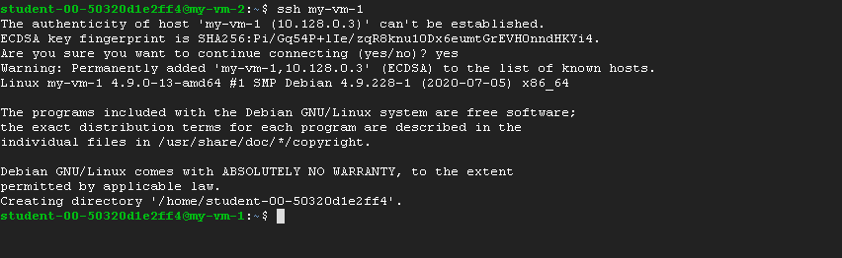

• At the command prompt on **my-vm-1**, install the Nginx web server:

sudo apt-get install nginx-light –y

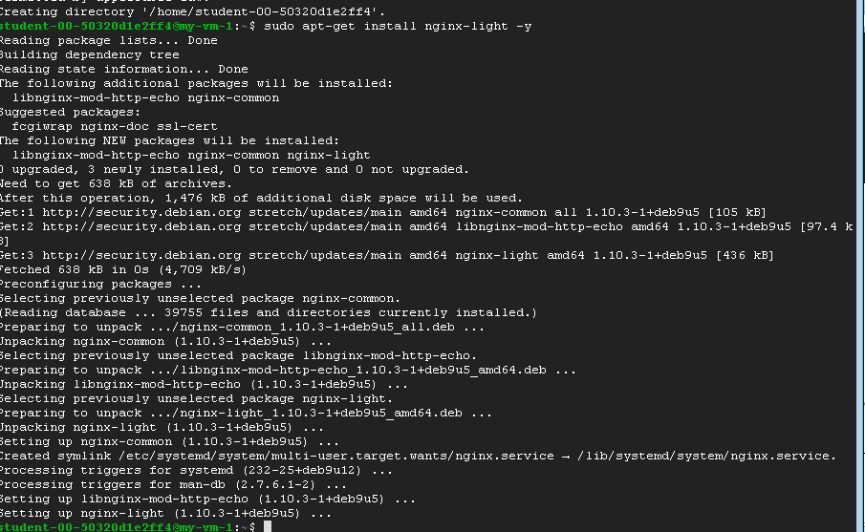

Use the **nano** text editor to add a custom message to the home page of the web server:

sudo nano /var/www/html/index.nginx-debian.html

Use the arrow keys to move the cursor to the line just below the h1 header. Add text like this, and replace YOUR\_NAME with your name:

Hi from YOUR\_NAME

• Press **Ctrl+O** and then press **Enter** to save your edited file, and then press **Ctrl+X** to exit the nano text editor.

• Confirm that the web server is serving your new page. At the command prompt on **my-vm-1**, execute this command:

curl http://localhost/

• The response will be the HTML source of the web server's home page, including your line of custom text.

• To exit the command prompt on **my-vm-1**, execute this command:

exit

• You will return to the command prompt on **my-vm-2**

• To confirm that **my-vm-2** can reach the web server on **my-vm-1**, at the command prompt on **my-vm-2**, execute this command:

curl http://my-vm-1/

1. The response will again be the HTML source of the web server's home page, including your line of custom text.
2. In the **Navigation menu** (), click **Compute Engine > VM instances**.
3. Copy the External IP address for **my-vm-1** and paste it into the address bar of a new browser tab. You will see your web server's home page, including your custom text.

If you forgot to click **Allow HTTP traffic** when you created the **my-vm-1** VM instance, your attempt to reach your web server's home page will fail. You can add a [firewall rule](https://cloud.google.com/vpc/docs/firewalls) to allow inbound traffic to your instances, although this topic is out of scope for this course.

**Congratulations!**

In this lab, you created virtual machine (VM) instances in two different zones and connected to them using ping, ssh, and HTTP.

**End your lab**